Reactions on Painting
Student’s Name
Institutional Affiliation

Reaction on Paintings
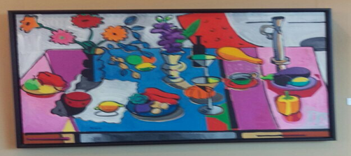
This picture is located in the student center of the University, and it captures a painting that espouses an artist’s impression of a table that has been typically set up for a course meal perhaps dinner. One may observe a candle holder on the extreme right of the painting which is used to support a flattering warm, glow of a candlelight which sets a formal ambiance during meals. Additionally, an individual may notice a vase with flower heads that are aimed at radiating elegance by spurring a festive feeling. In the middle of the painting, there are wine glasses together with a bottle of wine which typically served after meals as digestives. There are also different types of fruits and vegetables which serve as part of the course meal, and one may notice a piece of steak at the right end of the painting. Moreover, one may also see the cloth table which is contrasted using placemats such as the one that is placed on the coffee mug. In general, one may conclude that the artist’s visual impression was aimed at capturing a dinner set which depicts a typical home meal thus eliciting an emotion of calm and the feeling of safety.
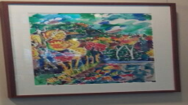
The picture illustrates a painting of a stretch of trees which is similar to a forest and is located at the student center. At the foreground of the painting, one may notice the presence of a lake or swampy area that is covered with vegetation. In the background of the painting, there are a group of hills which merge with the seemingly cloudy sky at the horizon. One may interpret that the artist had the intention of painting a serene atmosphere by capturing the tranquillity that is characteristic of forested areas. Moreover, such a painting may be perceived as inspiring a feeling of relaxation and calm as one may associate the forested area with sporting activities in nature such as hiking or fishing.
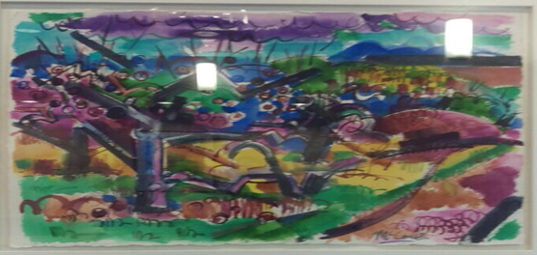
The photograph captures a painting which is located in the student center, and it demonstrates a water body which appears to be polluted. Much of the waste may be seen floating on the water body with the toxicity of the substances seemingly spreading towards land. The land may be perceived as being a victim of pollution as it natural green color is apparently fading away and giving way to a yellowish hue. Additionally, one may argue that irresponsible dumping may have occurred on land due to human activities such as discharges of untreated waste into adjacent water bodies. As a result, one may conclude that the painting is intended to evoke emotions that encourage the need for environmental protection by depicting the adverse effects of pollution.
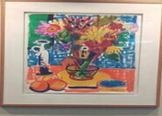
This photo is located in the student center, and it captures a center-piece which is placed at the central location of most dinner tables. The piece of artistry comprises of a vase that is filled with a bouquet of flowers. Adjacent to the flower vase is a white candle holder which is used during lighting to support selected candles which are lit to provide an ideal mood. Furthermore, there is a cloth comprising of fine linen that is laid over the table, and on top of it, there are placemats which are designed to protect the cloth table. There are also two fruits presumably oranges which are in the foreground of the painting. One may conclude that such a painting depicts a typical table setting in most homes thus creating a sense of belonging and leisure while hanging out at the student center.
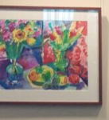
The photograph of this painting was taken at the student center, and it seemingly captures the layout of a garden of flowers. The flower on end resembles that of a sunflower which is commonly associated with bright emotions and is commonly given to someone as a gesture of appreciation. Additionally, the choice of colors in the painting depicts a proper blend of green and yellow which may be associated with vegetation in a calming and serene setting such as nature

